helping

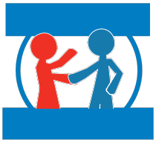Where to get help
each other

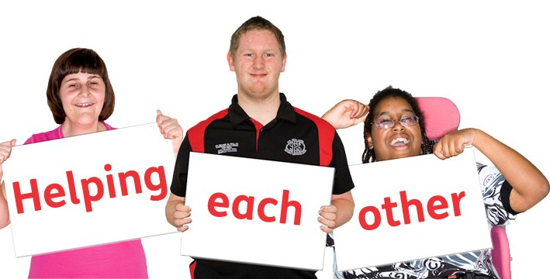

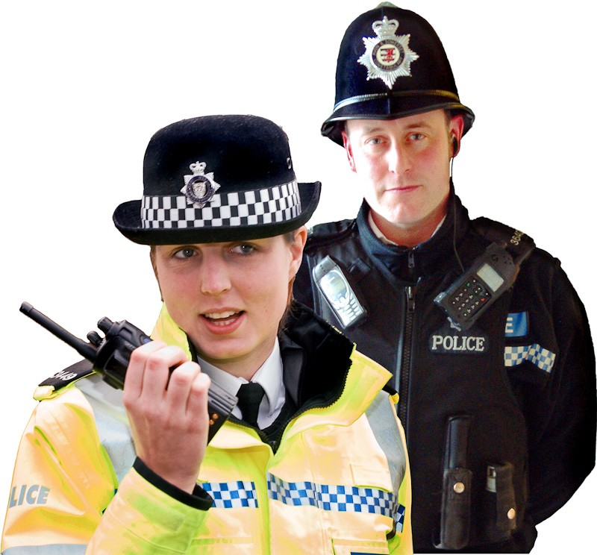

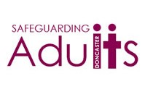

Project website: www.arcuk.org.uk/blog/ helping-each-other/

If you think you, or someone you know is being sexually exploited.

You can call...

The Police 999
(If someone is in danger right now)

The Police 101
(If someone is not in immediate danger)

Childline 0800 11 11

Safeguarding Children: 01752 308600

Safeguarding Adults: 01752 668000

Plymouth People First: 01752 773333

