Us Too project 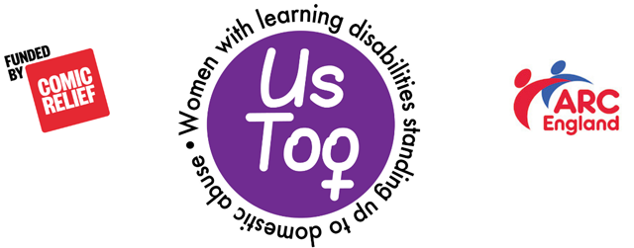
Online Peer Workshop

Teaching Plan: Week Two (1hour 15mins)

By the end of today we will have:

- Reminded ourselves about the last session
- Found out a bit more about each other
- Talked about what a relationship is and the different kinds of relationship
- Talked about the difference between good and bad relationships.
- Thought about what makes a good boyfriend/girlfriend.
- Discussed good and bad rules for relationships.

Programme

Timing | Topic | Activity | Resources
20 mins.  K | Introductions | Input  Remind people of our names. Go round the group asking their name and something they like that begins with the same letter as their name.  What we are going to do.  What we did last week.  - Ask people what they can remember.  - Read the slide.  Checking In  - Ask people if they were OK after last week.  - Do they want to ask or say anything?  Group rules  Here are the rules you agreed last time  Our rules  Confidentiality | Slides 24 – 25  Slide 26  Slide 27  Slide 28  Slides 29  Slide 30  Slides 31 – 33  Slide 34
10 mins. | Ice breaker | Get the group to decide:  - Who has got the most unusual middle name?  - Met someone famous?  - The coolest pet?  - The best way to relax? | Slide 35
5 mins. | Relationships | Ask learners what a relationship is?  Wordstorm  Ask the group what are the different relationships they have?  This may include:  - Family.  - Boyfriend/girlfriend.  - Mates/friends.  - Staff.  - Pets.  - Online friends. | Slide 36
5 mins. | Perfect Partner | Tell the group we are now going to look at boyfriend/girlfriend relationships.  - Ask the group who their perfect partner would be?  - Why?  Say we are now going to talk about what makes a good boyfriend or girlfriend. | Slide 37
20 mins. | Good and bad relationships | Small group work  Break learners into two groups.  Give each group a set of cards.  Ask them to decide which are the most important things in a boy/girlfriend?  Feedback:  There is no ‘right’ answer.  Are there any cards you would add?  What would it be like if your boy/girlfriend was the opposite of these? | Perfect Partner cards  Slide 38
10 mins. | Good and bad rules | Input:  Read from the PowerPoint.  Talk them through the good rules.  Whole group discussion  Ask them if these rules are good or bad (OK or not OK)?  Get the group to think about the words ‘always’ and ‘must’.  How can we turn bad rules into good rules? Take out ‘always’ and ‘must’? | Slide 39  Slides 40 - 43  Red and green cards
5 mins. | Support  Closing round  Thanks for coming | It is OK to call [emergency and support line numbers]  Ask each person what makes them feel loved.  Thank the group and say you will see them again next week. | Slide 44  Slide 45  Slide 46

