How to host (run) a Zoom meeting

Note: You will need to tailor this to the individual’s needs at the highlighted points.

1. | Go to the Zoom sign in:  https://zoom.us/signin | 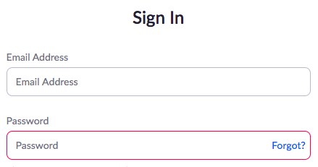
2. | Put in this email:  [Add email address here] | [Add a screen shot of the sign in box on Zoom here]
3. | Put in this password:  [Add your password here]
4. | Click on  Sign In
5. | Click on Meetings under the Profile heading | 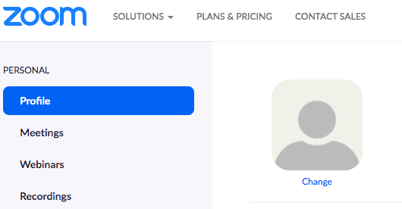
6. | A list of your upcoming meetings will come up.  Click on the meeting you want to start. | 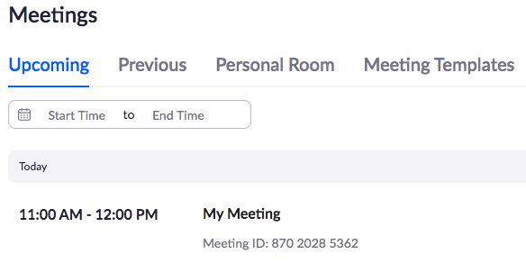
7. | This takes you to a new page.  Click on Start this Meeting | 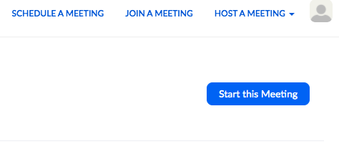
8. | You will see your face  There will be a box in front  Click on Join with Computer Audio | 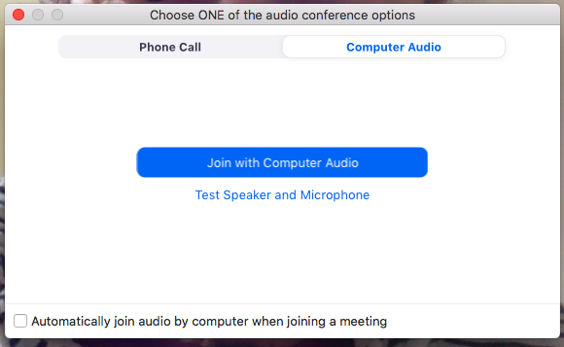
9. | You will see your face with this screen. | [Add a screenshot of the person’s face here]
To let other people into the meeting  Click on Participants at the bottom. |  | 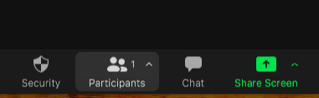
a) | A list of people waiting comes up on the right of your screen.  Click on Admit or Admit All to let them in. | 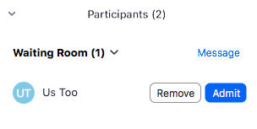
b) | To finish the meeting click on End | 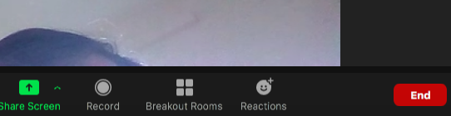
c) | Then click on End Meeting for All. | 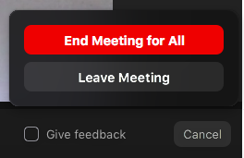
To share your screen

 | Click on Share Screen at the bottom. | 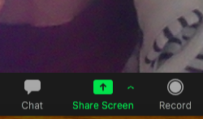
 | A box comes up.  Click on Share. | 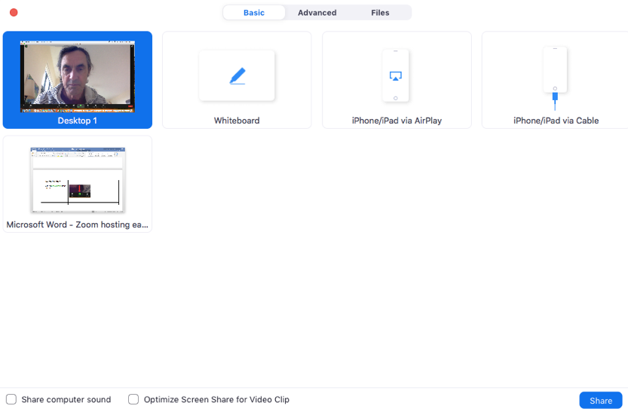
Everyone can now see your screen. You can now open and run PowerPoint.

 | To stop sharing your screen click on Stop Share at the top. | 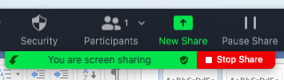
To use breakout rooms

a) | Click on Breakout Rooms at the bottom. | 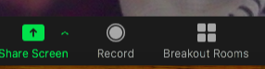
b) | A new box comes up.  Choose the number of rooms you want.  Then click Create | 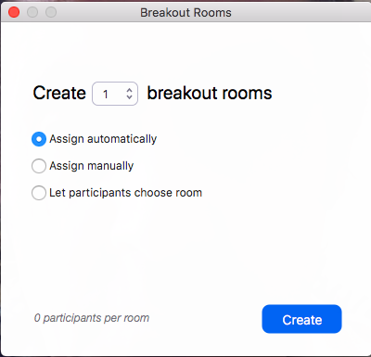
c) | A new box comes up.  It will have names split into groups.  Click on Open All Rooms
d) | To close the rooms click on Close All Rooms.  People have one minute to leave the room they are in.

