How to schedule (set up) a Zoom meeting

Note: You will need to tailor this to the individual’s needs at the highlighted points.

1. | Go to the Zoom sign in:  https://zoom.us/signin | 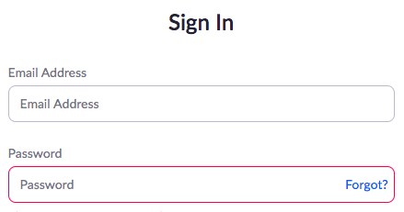
2. | Put in your email:  [Add email address here] | [Add a screen shot of the sign in box on Zoom here]
3. | Put in this password:  [Add your password here]
4. | Click on  Sign In
5. | Click on  SCHEDULE A MEETING | 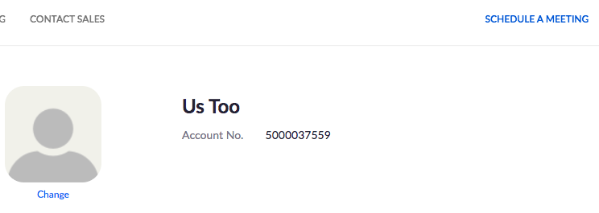
 | There are lots of choices. Here are the basic ones you must do . . .
6. | Set a date  Click on the calendar.  Choose a date. | 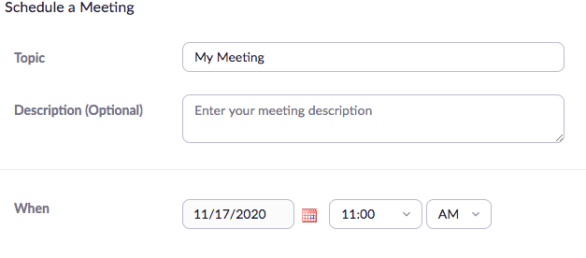
7. | Set a time  Click on the time.  Choose a time.  Choose morning (AM) or afternoon (PM) | 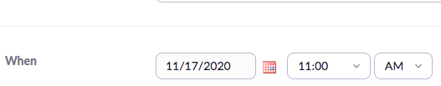
8. | Password  It is easier for other people if you turn the passcode OFF.  Click on the tick to turn it off. | 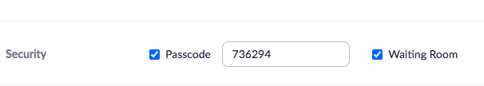
9. | Video  Turn the video buttons ON so you can see other people!  Click where is says ON. | 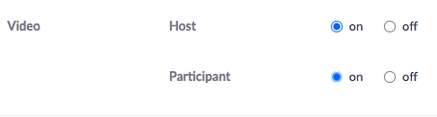
10. | Click where it says Save | 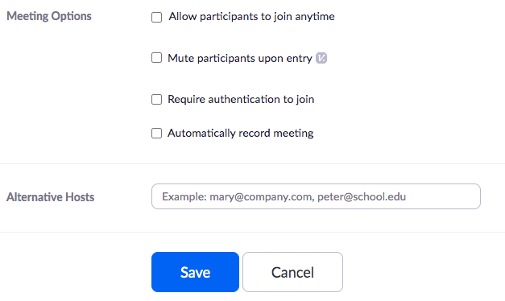
 | You now go to a new page which shows your meeting.
11. | Invite other people to your meeting.  Click on Copy Invitation | 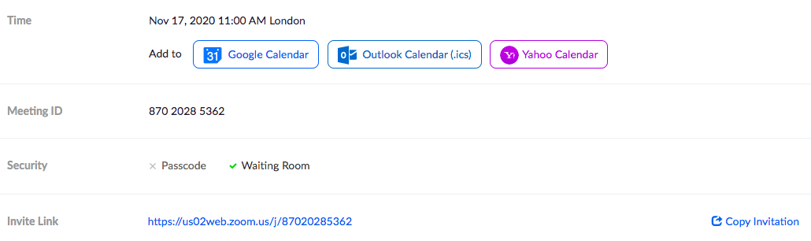
12. | You now go to a screen which shows your invite.  Click on Copy Meeting Invitation.  This copies your invite on to your clipboard. | 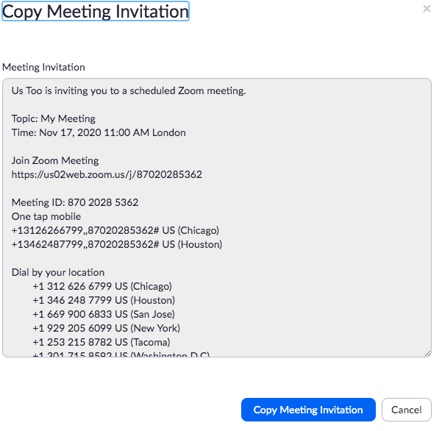
 | You can now send the details to other people in an email.
13. | Start an email.  Choose who you want to send it to.  Choose a subject (like Zoom Meeting). | 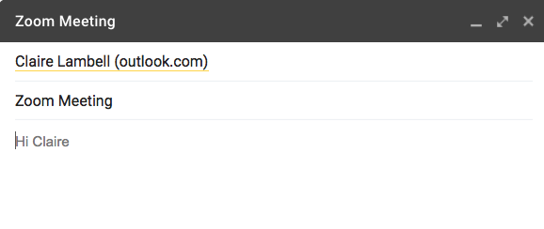
14. | Paste the meeting details into your email. | 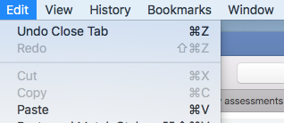
15. | Send the email.  Job done! | 