Model policy on Domestic Abuse & Sexual Violence for Learning Disability and Autism services

Introduction
According to 2020 ONS data, people with learning impairments are (just under) three times more likely to experience domestic abuse than their neurotypical counterparts. (See Appendix 1 for the definition of abuse).
The report states that:
- Disabled women were more than twice as likely to experience domestic abuse than non-disabled women. Disabled men were also more than twice as likely to have experienced domestic abuse than non-disabled men.
- Disabled people aged 16 to 24 years were almost three times more likely to have experienced any form of domestic abuse in the last year than non-disabled people of the same age.
- In the year ending March 2020 disabled people aged 16 to 59 years old who reported a mental health, a social or behavioural, or a learning impairment tended to have experienced the highest levels of domestic abuse in the last year.
This policy has been written to address this higher level of domestic abuse.

The Policy
This policy applies to all (insert name of learning disability provider) trustees, staff, volunteers, members (or service users), visitors and professional partner agencies working with the provider.
This policy has been developed in accordance with the principles established by the Domestic Abuse Act 2021 and in line with the following:
• (Insert name of local authority) Multi-Agency Policy and Procedures
- (Insert name of local authority) DA Strategy 2018-21
- (Insert name of local authority) DA Pathway
- Sexual Violence and Sexual Harassment between Children – May 2018
- The Equality Act 2010
- Mental Capacity Act 2005
- Serious Crime Act 2015: Section 76 Controlling or Coercive Behaviour in an intimate or family relationship
- No Secrets: Guidance on Developing and Implementing Multi Agency Policies and procedures to Protect Vulnerable Adults from Abuse; DH 2000
Domestic abuse legislation covers not only adults, but also young people aged 16 years and older. Children under 16yrs who are subject to abuse and/or violence are dealt with under the safeguarding policy and procedures and orders under the 1989 Children’s Act.
The overall responsibility for ensuring adherence to and implementation of this policy lies with the Board of Trustees and Chief Executive Officer.
The Policy will be reviewed internally on an annual basis usually by the Head of Safeguarding.

Statement
(Insert name of learning disability provider) is fully committed to doing what it can to prevent domestic and sexual abuse, to encourage the reporting of abuse, and to support those who have experienced abuse.
We recognise our responsibilities to take all reasonable steps to promote safe practice and to protect people from abuse.
(Insert name of learning disability provider) believes that:
• The welfare of all staff and all members / service users is important.
• All, whatever their age, culture, ability, gender, language, ethnicity, religious or spiritual beliefs and/or sexual identity, have the right to protection from abuse.
• All allegations, reports or suspicions of abuse should be listened to, taken seriously and responded to in a swift and appropriate manner.
(Insert name of learning disability provider) aims to provide a safe, caring, positive and stimulating environment. (Insert name of learning disability provider) will ensure that:
• All people drawing upon the services of the organisation will be treated equally and with respect and dignity.
• Staff and volunteers will:
  - Undertake relevant and appropriate development and training in relation to domestic abuse and sexual violence (separately and in addition to that of the more general Safeguarding training provided by the organisation).
  - Be trained to be fully aware of the Indicators of Abuse (See Appendix 2)
  - Be kept updated with regard to changes in legislation and policies relating to domestic abuse and sexual violence.
  - Regularly and pro-actively ask of the people who draw upon services ‘how is life at home?’ and/or ‘how are things with your partner?’
  - Provide a safe space where negative experiences can be discussed.
  - Ensure that healthy relationship education takes place on an annual basis (or more often).
  - Ensure that members / service users are able to meet and form positive relationships with other members / service users.
  - Be fully aware of their responsibilities for safeguarding, and fully understand the correct process for reporting concerns.

Responsibilities
(Insert name of learning disability provider)’s Board of Trustees understands and fulfils its domestic abuse and sexual abuse responsibilities by:
- Ensuring that measures are in place to have oversight of how (Insert name of learning disability provider) delivers its responsibilities.
- Ensuring domestic and sexual abuse is a standing agenda item for at least one Board meeting per annum, and a report is presented by the Head of Safeguarding, highlighting any gaps and concerns.
- Nominating a Domestic and Sexual Abuse Trustee, who will support the Head of Safeguarding and the CEO in compiling these reports and be available as and when required for cases that have been escalated due to sensitivity or Police investigations.
- Ensuring the Chair or, in their absence, the Nominated Domestic and Sexual Abuse Trustee makes themselves available to liaise with relevant agencies if an allegation is made against the CEO.
- Ensuring that, in the event of an allegation or incident where a conflict may arise by the board being involved, an external oversight committee can be called upon to undertake the investigation.
The Board will ensure that (insert name of learning disability provider)’s procedures for safeguarding and protecting members / service users from harm are maintained in line with (insert name of local authority) procedures.
The CEO will simultaneously ensure that (insert name of learning disability provider) has a Designated Domestic and Sexual Abuse Champion in place.
The Designated Domestic and Sexual Abuse Champion will offer advice as to the correct action to take following a concern raised, and that the (insert name of learning disability provider) Domestic and Sexual Abuse Policy is being fully adhered to. He or she will also be responsible for:
- Domestic and sexual abuse training
- Building a working relationship with local Domestic Abuse services
The CEO and the Head of Safeguarding will fulfil their responsibilities by:
- Ensuring the Domestic and Sexual Abuse Policies are implemented and understood across the organisation and reviewed annually.
- Ensuring that safe and effective recruitment polices and disciplinary procedures, which adhere to Safer Recruitment Practices, are in place.
- Ensure that the organisation meets all Section 11 Audit requirements.
- Ensure that relevant resources and adequate training is provided across all levels of the organisation to meet safeguarding responsibilities as required by the Local Authority Training Frameworks.
Heads of Programmes and their Senior Teams will fulfil their responsibilities by ensuring that:
- Staff and volunteers have been given opportunity to access, read and understand their responsibilities as set out in the (Insert name of learning disability provider) Domestic and Sexual Abuse Policy.
- Staff and volunteers are allocated time and are supported to complete domestic and sexual Abuse training. This training will be reviewed and validated by a line manager.
- Staff and volunteers are supported in raising a concern and feedback is given in a timely manner. (Insert link to learning disability provider’ s whistleblowing policy or process by which concerns can be raised without prejudice).
- Any domestic and sexual abuse concerns raised by a member are addressed, logged and monitored by (insert tile or responsible person).
- They escalate to the Head of Safeguarding any concerns that may need Social Care or Police intervention.
All staff and volunteers working within (insert name of learning disability provider) should understand that domestic and sexual abuse is everyone’s responsibility. This means that they should always consider what is in the best interests of the individuals with learning disabilities supported by the organisation.
In order to do this all staff and volunteers will:
- Read, understand and adhere to the (insert name of learning disability provider) Domestic and Sexual Abuse Policy, and all related policies, so that a safer working practices environment is created.
- Be supported to complete all relevant domestic and sexual abuse training within the timeframes allocated with training attendance and outcomes being reviewed/validated by a line manager.
- Understand the specific reasons people with a learning disability, autism or both, are more vulnerable to abuse
- Understand the different categories of abuse, and how to recognise the signs as listed in Appendix 2.
- Be prepared to identify people who may benefit from early help i.e. providing support as soon as a problem emerges.
- Understand their responsibility to report and flag any concerns that a child/young person is being, or is at risk of being, abused or neglected. This includes reporting any concern they may have regarding the behaviour of another staff member or volunteer towards a child or children.
- Understand the line of accountability for reporting Domestic and Sexual Abuse concerns, and be fully aware of the organisation’s safeguarding lead, all deputies and their role within the organisation. This will be made available in an organogram as part of the training programme and held within staff resources/easy access for reference somewhere in the organisation,
• If appropriate, liaise with other agencies, contribute to safeguarding assessments and attend child protection meetings/core groups/conferences.

Training
At (insert name of learning disability provider) the Head of Safeguarding and the Domestic and Sexual Abuse Champion will work closely with HR to ensure appropriate training is provided to All Senior Teams, staff and volunteers. It is mandatory that:
- All staff and volunteers working with children and young people undertake Domestic and Sexual Abuse Awareness training within their first year of employment, and attend refresher training every two years.
- The Domestic and Sexual Abuse Champion attends events/workshops relevant to his or her role.
Training should cover:
- What is domestic abuse, and what is sexual abuse
- Recognising signs of abuse
- The reasons people with learning disabilities are at higher risk
- The reasons people with learning disabilities are less likely to report/are less likely to be reported/are less likely to be taken seriously when reported
- How to encourage reporting
- Dealing with a disclosure, to include signposting to local DA and other support services
- Supporting a victim
- Approaches that make it less likely
- Importance of recording
- Available, free resources
Links to training materials can be found at www.arcengland.org.uk
In addition, the Domestic and Sexual Abuse Champion will send domestic and sexual abuse updates and reminders, as required. At least once a year he or she will provide staff with the relevant skills and knowledge to safeguard members / service users effectively.

Disclosures
Staff should listen to and carefully document any disclosure. No pressure should be placed on the victim of domestic abuse to disclose, and care should be taken not to press for detail if the alleged perpetrator may overhear.
If a young person/child makes a disclosure, then the (insert name of learning disability provider) Safeguarding Procedures will be followed.
In addition, all staff will abide by the principles of Safe Enquiry, and will ensure:
- Confidentiality and privacy (any conversation should take place where voices cannot be overheard)
- Adequate time is allowed (the person should not feel rushed)
- Advocacy is used, and made available in a timely fashion, if appropriate
- An explanation is given for any questions
- Direct questions are asked
- He or she is honest about limits of confidentiality
- The abused person understands the next steps, and where to go for further help
- All disclosures are recorded carefully and confidentially

Prevention
We recognise that (insert name of learning disability provider) plays a significant part in the prevention of harm to our members / service users by providing effective lines of communication with trusted adults, supportive friends and an ethos of protection.

Positive well-being – supporting members / service users
We recognise that our members / service users are vulnerable and are more likely to experience abuse. Therefore, staff will be alert to the signs of Domestic and Sexual Abuse and report concerns via our safeguarding procedures.
We recognise that (insert name of learning disability provider) may provide the only stability in the lives of young people who have been abused or who are at risk of harm; we therefore take our responsibilities seriously.
We accept that research shows that the behaviour of a young person in these circumstances may range from that which is perceived to be normal, to aggressive or withdrawn. Changes in mood, patterns of behaviour, injury and responses to stimuli around them may be wrongly attributed to their disability. Staff are therefore trained to question behaviours and be professionally curious about changes noted; all staff are required to be prepared to ‘think the unthinkable’, raise concerns and ensure safeguards are in place.
We recognise that members / service users with communication difficulties may be especially vulnerable, and for this reason we link behaviour with safeguarding, ‘listening to behaviours’, acknowledging that not all members / service users will be able to verbalise what may be troubling them.
Staff understand the need for a culture of vigilance to be present in (Insert name of learning disability provider) to support safeguarding. This includes awareness and sensitivity to changes in the attitudes of members / service users, which may indicate they are at risk of domestic or sexual abuse.
Through training, staff and volunteers are aware that members’ / service users’ behaviours may pose a risk to themselves and their peers. When a member of staff or a volunteer becomes aware of this type of behaviour, they must flag this to a member of the Senior Team who will assess and give appropriate advice. All concerns will be dealt with sensitively, confidentially and in line with (Insert name of learning disability provider)’s Procedures and Policies.
At (insert name of learning disability provider) we will support all members / service users by:
• Encouraging the development of self-esteem, resilience and critical thinking.
• Promoting a caring, safe and positive environment within (Insert name of learning disability provider).
• Monitoring all absences and promptly addressing concerns about irregular attendance.
• Liaising and working together with other relevant support services and agencies.
• Seeking appropriate advice, support and guidance to enable us to critically evaluate Domestic and Sexual Abuse information and concerns, and to act on them appropriately.
We will also provide learning opportunities which will build the skills of our members / service users which will enable them to stay safe from both physical and emotional harm and to know to whom they should turn for help. Members / service users are encouraged to seek help and support and are provided with information about where and how to access this, if they are encountering problems at home or elsewhere.

Cultural Issues
At (insert name of learning disability provider) we are aware of the cultural diversity of the community around us and seek to work sensitively to consider the unique culture of our members / service users and their families as they relate to domestic abuse.
As a staff team we are aware of the harm that can be caused by practices linked to culture, faith and beliefs. We promote awareness through training and access to resources. Staff will report concerns about abuse linked to culture, faith and beliefs in the same way as they would report other abuse concerns.
At (insert name of learning disability provider) we are aware of a range of practices and beliefs which are classified as domestic abuse; we include within this honour-based abuse, female genital mutilation, forced (but not arranged) marriage and breast ironing. Women with learning disabilities are three times more likely to be in a forced marriage (a forced marriage is where one or both people do not or cannot consent to the marriage and pressure or abuse is used to force them into the marriage).
At (insert name of learning disability provider) we understand that whilst we try always to work in partnership with families, sharing information with a parent or member of the family is not appropriate in some instances where there may be cultural differences of opinion on abuse. Staff have a duty to report concerns to the (insert name of learning disability provider) Senior Teams who will liaise with the Head of Safeguarding, working closely with police and/or the Forced Marriage Unit, and follow advice given regarding protective strategies to safeguard the member.
All practitioners working with victims of forced marriage and honour-based violence need to be aware of the ‘one chance’ rule. That is, they may only have only one chance to speak to a potential victim and may only have only one chance to save a life. This means that all practitioners working within statutory agencies need to be aware of their responsibilities and obligations when they become aware of potential forced marriage cases. The one chance rule could also apply to all serious cases of domestic abuse where there may be a risk of death.

Peer-to-Peer Abuse
At (insert name of learning disability provider) we believe all our members / service users have the right to attend our services to learn and develop in a safe environment free from harm. We recognise that some safeguarding concerns can occur via peer-to-peer abuse.
All (insert name of learning disability provider) staff recognise that peer-to-peer issues may include sexual abuse.

Summary
At (insert name of learning disability provider) we are fully committed to doing what we can to prevent domestic and sexual abuse, to encouraging the reporting of abuse, and to supporting those who have experienced abuse.
We understand the importance of developing safe relationships with members / service users where they feel they can freely discuss their domestic and sexual relationships.
We are committed to ensuring all staff are trained to understand the increased vulnerability of those they work with, in relation to all the different forms of domestic abuse. Staff will be trained to recognise the signs of abuse, to manage disclosures, and to support members / service users who have experienced abuse. In addition, the training will aim to give staff the confidence to pro-actively ask, on a regular basis, about how things are at home and how things are with their partner.
Access to relevant resources will be provided to all staff to help them implement this commitment.

APPENDIX 1
Definitions of Abuse
In simple terms, domestic violence and/or abuse is said to have occurred when people hurt family members or partners with their words or actions, take their money, or try to control them.
More formally, Women’s Aid defines it as any incident or pattern of incidents of controlling, coercive or threatening behaviour, violence or abuse between those aged 16 or over who are or have been intimate partners or family members, regardless of gender or sexuality. This includes stalking and harassment, FGM and forced marriages.
The cross-government definition is similar. It defines it as ‘Any incident or pattern of incidents of controlling, coercive, threatening behaviour, violence or abuse between those aged 16 or over who are, or have been, intimate partners or family members regardless of gender or sexuality. It can encompass but is not limited to the following types of abuse: psychological, physical, sexual, financial, emotional’.
The Power and Control Wheel (shown below) was developed by the Domestic Abuse Intervention Programs in Duluth, MN. (1981). It is believed to be the best diagrammatic depiction of domestic abuse and coercive control.

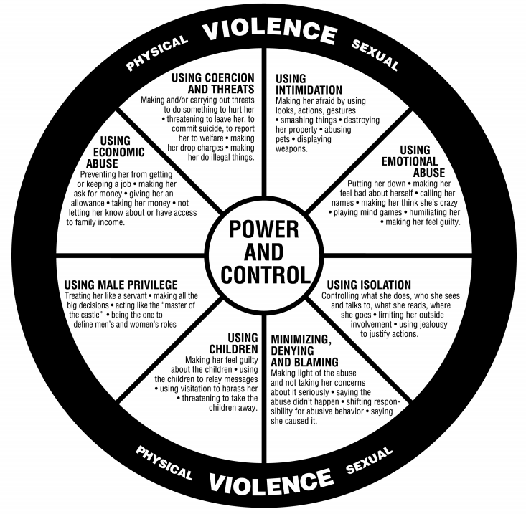

An alternative ‘disability friendly’ Power and Control Wheel is shown below:

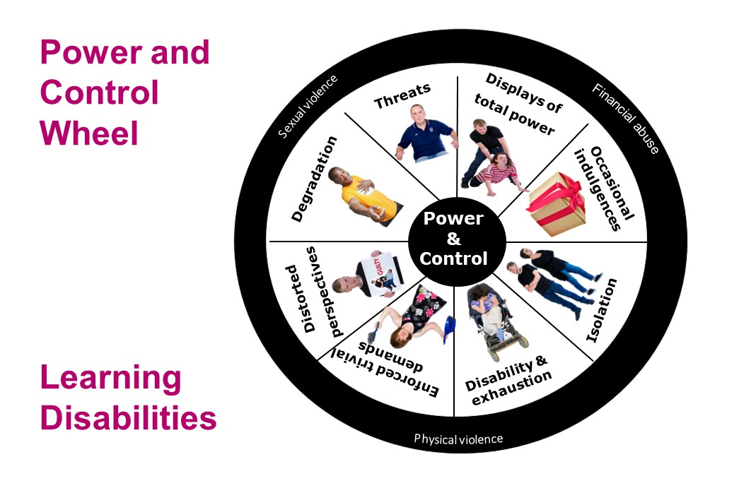

Sexual abuse is unwanted sexual activity, with perpetrators using force, making threats or taking advantage of victims not able to give consent.
Sexual abuse may involve physical contact, including assault by penetration (for example, rape or oral sex), or may involve non-penetrative acts such as masturbation, kissing, rubbing and touching outside of clothing. It can also include non-contact activities, such as involving looking at children, or in the production of, sexual images, watching sexual activities, encouraging children to behave in sexually inappropriate ways, or grooming a child in preparation for abuse (including via the internet).
Sexual abuse is not solely perpetrated by adult males. Woman can also commit acts of sexual abuse, as can other children.

APPENDIX 2
Indicators of Abuse
There are various signs that might suggest someone is being, or is at risk of being, abused. These include the following;

  - Seeming afraid or anxious to please their partner.
  - Going along with everything their partner says and does.
  - ‘Checking in’ often with their partner to report where they are and what they are doing.
  - Talking about their partner’s temper/jealousy/possessiveness.
  - Having frequent injuries, with the excuse of “accidents.”
  - Dressing in clothing designed to hide bruises or scars (e.g. wearing long sleeves in the summer or sunglasses indoors).
  - Rarely going out in public without their partner.
  - Having limited access to money, credit cards or the car.
  - Having low self-esteem, even if they used to be confident.
  - Being depressed, anxious or suicidal.

https://www.ons.gov.uk/peoplepopulationandcommunity/healthandsocialcare/disability/articles/outcomesfordisabledpeopleintheuk/2020#crime
https://www.legislation.gov.uk/ukpga/2021/17/introduction/enacted
https://www.legislation.gov.uk/ukpga/2021/17/part/5/crossheading/orders-under-section-9114-of-the-children-act-1989/enacted
https://www.legislation.gov.uk/ukpga/2004/31/contents
https://assets.publishing.service.gov.uk/government/uploads/system/uploads/attachment_data/file/894428/Forced_Marriage_Unit_statistics_2019.pdf
https://www.womensaid.org.uk/information-support/what-is-domestic-abuse/
https://assets.publishing.service.gov.uk/government/uploads/system/uploads/attachment_data/file/157800/domestic-violence-definition.pdf

