Learner Registration Form
Please complete form in block letters

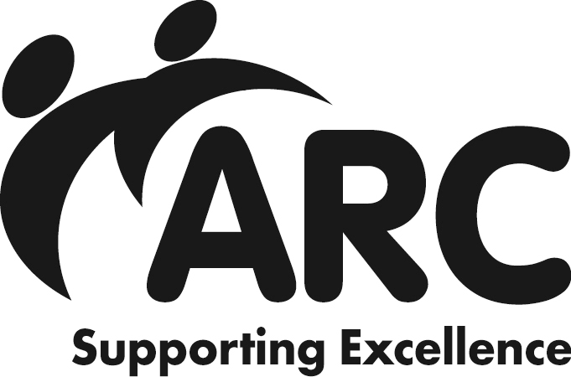
please photocopy as necessary

First Name

Family Name

Date of birth (needed to register you with City & Guilds) Gender

Name/address of workplace
Postcode
City & Guilds registration number (if you have one)

Organisation Tel Direct Contact No

Your Email:

Organisation Name: Your Role/Title Qualification to be enrolled for:

Diploma
Certificate
Award
Units only (quantity )

Qualification Title

Pathway (if appropriate)

Level:
Entry 1
2 3 4 5

Assessment Agreement discussed and agreed by:
Name of Learner Signature
Name of Assessor Signature
Name of Internal Verifier / IQA Signature
Name of Development Office Signature
Please complete the following to help the centre monitor its equal opportunity policy.
Have you any particular requirements which would have to be met in order to undertake this award?

Please tick box: Cheque included
Please note learners will not be registered until payment is received.

Please invoice

Please return this completed form along with, the ULN Registration form form & the Data Protection Privacy Consent form to:
the Initial Assessment

ARC Training Services, ARC House, Marsden Street, Chesterfield, Derbyshire S40 1JY
ATS Form Q1- V1 22/03/2021

