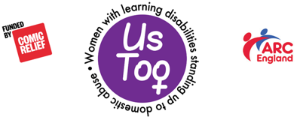

INTERVIEW PROTOCOL

Before the training, the training supporter and training team should have a meeting to agree what questions will be asked and what the training team would like to include in their answers.

Team members should be encouraged to talk about the learning from their experiences of abuse rather than details of the abuse itself.

The training supporter should make a note of agreed content so that team members can be prompted if necessary.

Before starting interviews in the workshop:

a) warn learners that you will now be talking to the training team about their experiences of abuse. Say that the interviews are about the learning from the experiences and not about details of abuse. However, this can still be triggering for any learners who have had their own experiences of abuse, and is likely to be upsetting to anyone. Additionally, whilst the interviews focus on learning details of abuse still sometimes emerge. Remind learners of the ground rules and confidentiality.

b) ask team members if it is OK to do the interview. Remind them that the stories are theirs, and that they can change their mind at any time, or refuse to answer any of the questions. Tell them that decision is theirs, it will not be challenged, and there will be no comeback.

After the interview you can ask team members if it is OK if any of the learners have questions for them. Remind them that the rules above still apply and they can refuse to answer any question.

Check that team members are OK after the interviews, as it can be upsetting. Remind them that you will have a debrief when the workshop has finished.

