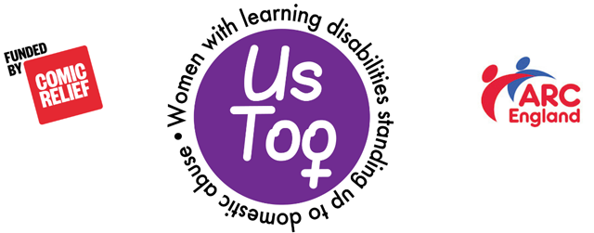
Us Too Escape Plan

How to get out if you are in a relationship with someone who hurts, scares or controls you.

If you need to leave someone:

You can tell the Police what is happening and ask for help. | 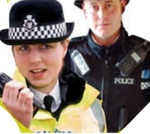 | How can you contact the Police?
You can call a Domestic Abuse helpline. |  | What is the phone number of your local helpline?
You can tell someone you trust and ask for help. |  | What are the names of two people you could trust to help?
You can have a code word to text a friend or support worker when you need help. This might be Now or Quick. | 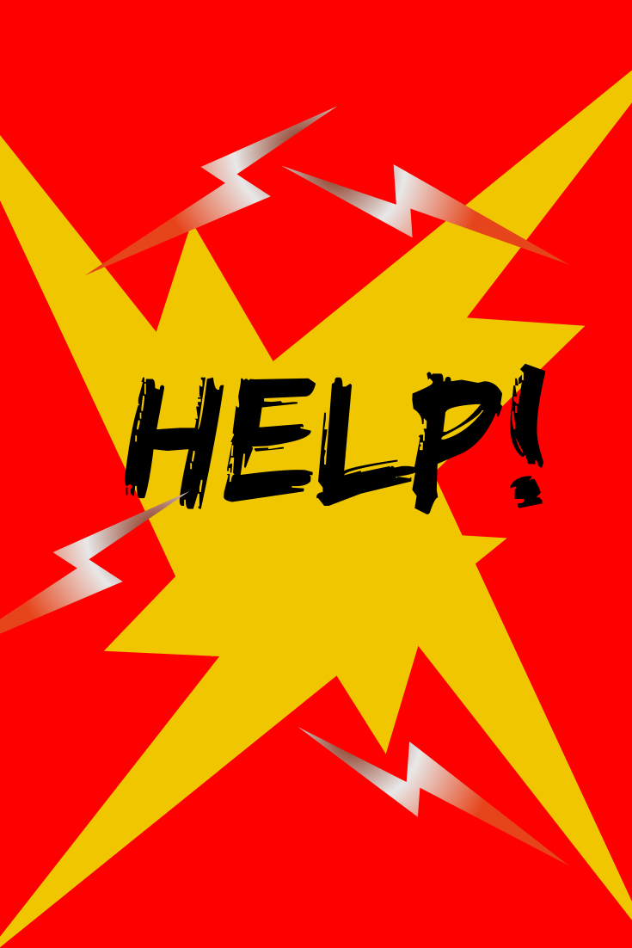 | What code word would you use?  Who would you ask for help?

You can keep a diary about bad things your partner does, and when.  It is safer to use a code.  This could be yellow dots for punches and kicks – blue dots for being shouted at – green dots for someone taking your money or using your cards – red dots for someone making you have sex when you don’t want to. |  | Who can help you make and keep a diary?
If you are getting abusive text messages, don’t delete them. Show them to the police when you are safe. | 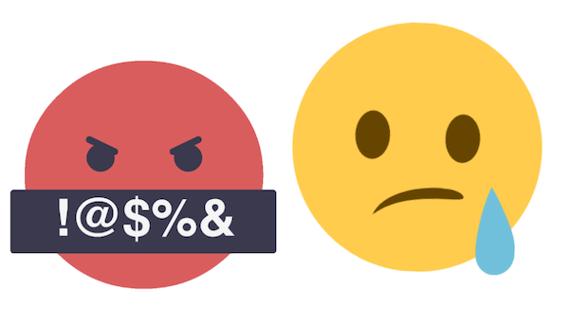

We say:
- Don’t tell the person who is hurting you that you are leaving
- Only tell people you trust where you are going
- Be careful not to leave phones with messages about what you are planning to do where the abusive person can find it
Keep your phone with you. Call 999 if you are frightened

Your escape bag
When you are planning to go pack a small bag with all the things you need. You can get a support worker or close friend keep the bag safe for you. What would you put in your escape bag?
What you might need |  | - or X
Medication.
Important papers:  - Birth certificate.  - National insurance number.  - Passport. | 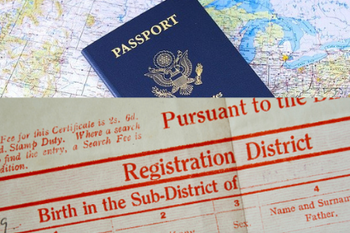
Money and bank cards.
Phone numbers:
- Police
- Domestic abuse helpline
- Support worker
Clothes

Toiletries | 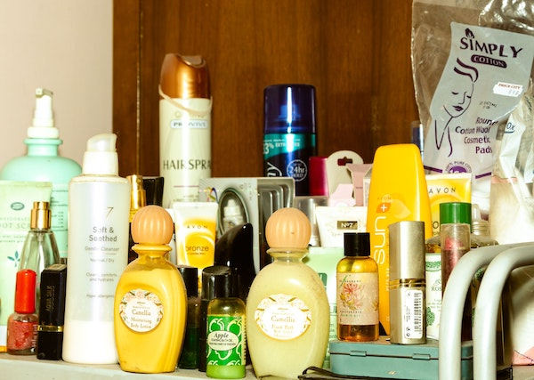
Something small and special – like a favourite toy or photograph. | 