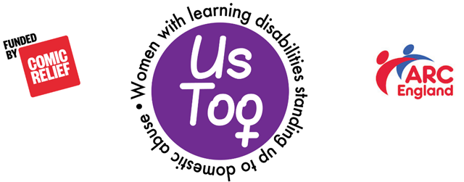
Us Too Project

Evaluation Quiz

Is it OK if your boyfriend or girlfriend hits you but says sorry and buys you some chocolates? |  | Yes or No
Is it OK if your boyfriend or girlfriend cares about you so much they tell you what to do the whole time? |  | Yes or No
Have you heard of domestic abuse? |  | Yes or No
Do you know what domestic abuse is? |  | Yes or No

