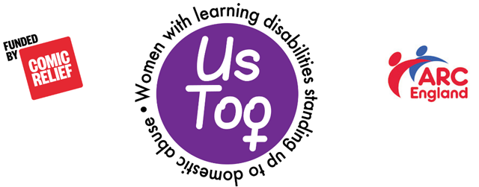

Misha case study: Feedback

Professional

- Talk to her – do what she wants
- Support her to report
- Refer to a Domestic Abuse service/MARAC
- Risk assessment, with Misha
- Support her to look at her options
- Capacity assessment
- Safeguarding referral
- “How does this make you feel?”
- Look at consequences/risks with her
- Make time for her/go at her pace
- Work sensitively
- Education on healthy relationships
- Does she know she is being abused?
- Look for evidence
- Refer for advocacy
- What other support does she have (e.g. family)
- Can she access a refuge?
- Find her a place of safety
- Complete a safety plan with her
- Give her helpline numbers
- Find counselling for her
- What about Jack? (Does he need help? Is he a danger to others? Does he have a learning disability? Has he been abused?)
- Are there any assessment tools?

